# Revel’s Profile Page - Design Documentation

## USER STORIES

(Considering users as primarily recruiters / Hiring managers)

### Home Page

Should grab attention and present clear navigation options

### Work page – Web Dev Portfolio (Most detailed section)

SBAT (should be able to) see a summary of my projects

ST they get an overall picture of my skills/experience in terms of:

* Languages
* Inclination to front/back/full-stack

SBAT see each project separately and in terms of its elements:

* Application (screenshots with descriptions) – Better way?
* Code (screenshots, comments included, and descriptions) – Better way?
* Documentation (files opening in web viewer)

ST they can either, click the project icon to view a new page with all project info and links to pages for each info type (Application, code, etc.) or, click a drop down menu on the project icon that lets them navigate straight to the info type they are interested in

### About me

SBAT get an immediate feel for my personality / passions / hobbies (use pictures, colour, animation, anything)

ST they can identify with me

SBAT to read a summary of my professional journey

ST they don’t have to go into the details (Consider breaking into heading to so they can quickly get to the info they are looking for:

* Where I’m going
* Where I came from

SBAT see the detail via a link to linked-in or suggest email me for CV

ST they know where to look for further detail on my professional journey

### Contact page showing my contact details

SBAT clearly see my phone number, email, linked-in, github and current location

ST they can easily contact me

## DESIGN DECISIONS

Starting out looking for inspiration I quickly developed a general idea of how I wanted my site to look: CLEAN; CRISP; BOLD and; CONTRASTING… - The Design Proposition.

Collected the inspiration on a mood-board in Canva:



After finalising general content to be included, I began thinking about general layout, aesthetics, functionality and user heuristics.

I decided on non-scrolling pages, where possible, to give it the feel of a book, catalogue, or a collection of specifically styled pages.

### Nav-bar

I wanted the **layout** to be striking but simple, so I gave the elements plenty of space and added a nice block of colour – an image I found on the web. I balanced the bold left-positioned image with the three navigation menu items on the far right.

**Aesthetically** I wanted it to be minimalist and striking so I used a solid black background with contracting white fine text, letters spaced out. (Giving things room seems to make them seem more important).

From a **functionality** and **user heuristics** point of view, I just opted for standard links and page transition.

### Home page

I wanted an unstructured **layout** that didn’t require much attention span to take in. Basically, I just wanted a full background picture and some brief but insightful, powerful text, and possibly some animation if time permitted. The navbar is also taller than other pages to balance the frame with such a large open space.

I found **aesthetic** inspiration from an item collected on my mood-board, which I immediately liked when I saw it and decided to use a picture of myself to immediately represent the purpose of site, of course it had to be a little creative too. I found a web-tool with the ability to detect and crop shape outlines and superimpose on a background. I also gave the image some opacity to blend in with the background colour (which I used on all pages for consistency – the background colour). The text I just sized and positioned in a way that I felt balanced the frame.

From a **functionality** and **user heuristics** point of view,

### About

I took the opportunity to include photos of myself which tell a story of my passions and lifestyle, choosing ones with colour to compliment the nav-bar picture and enhance the **aesthetics** of the page. For the **layout** I drew on the idea of a film strip, which I’d collected in my mood-board. I decided to put the strip horizontally across the bottom of the page to support the text and balance the frame.

The heading I wanted big, again just to be clear about the purpose of the page. The main text looked too long on a full screen so, for readability, I cut it down to about 50% width and then in the center position it didn’t align well with the heading, so I moved it left. For smaller screens, as the heading moves right, the text could begin to fill the width of the screen.

I originally wanted to put more information on this page regarding my education and professional experience however, didn’t want to overcrowd the page or scroll so instead I opted for a really nice ‘request CV’ button, which I placed in the larges empty space on the page (top right).

From a **functionality** and **user heuristics** point of view, I added links to appropriate words (‘linked-in’, ‘CV’ and ‘contact’) with commonly associated font styling. I also added an attractive ‘request CV’ button (which opens an email draft on the users pc) to entice users to get in touch.

### Contact

I used the same heading style as ‘about’ for consistency. My main concern was not having much content, which makes **layout** decision difficult/unclear but as previously mentioned, it’s also an opportunity to give things space, making them stand out. I decided on a centered rectangle with only the icons for each contact type – simply conforming to the design proposition and ticking some **aesthetics** boxes. I also included some text on the bottom right just to balance the frame.

From a **functionality** and **user heuristics** point of view, I just animated the contact icons to appeal to users. I opted for transitions that would encourage a click, specifically the grow transition. The color I choose to compliment the nav-bar image and general color scheme of the site.

### Work

I put the heading in the same place, again for consistency, but changed the style to something dramatic and more playful as my work portfolio is not yet substantial. My main concern was fitting the screenshots on the page **layout** due to their small internal text, so I decided to shrink them, thinking I could give the user a way to enlarge them later. To separate the works and compartmentalise them I put their screenshots between two, wider horizontal bars, in which I wrote the heading and footer. **Aesthetically** the bars work but I may also consider replacing this layout with headed and captioned boxes.

From a **functionality** and **user heuristics** point of view, the main challenge here was to allow users to enlarge the screenshots so they could read them comfortably. I did this with a simple scale and translate transition. It is a click and hold function which may be better as a multiple click function but they both have their pros and cons so final decision is pending user feedback. I made the boarders thinker on the screenshots than the header and footer bars to stand out of the page relatively. Finally, there is a hover effect over the screenshots to entice a click so that they will discover the hidden enlarge function.

## WIRE FRAMES

After collecting inspiration on the mood board, the first thing I did was to draw my wire frames, which I just did the old-fashioned way, pen and paper:

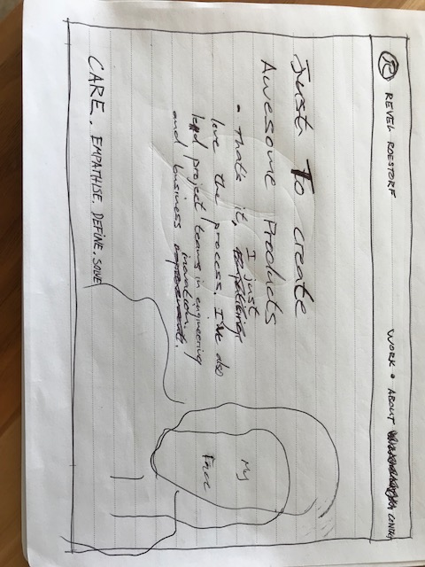

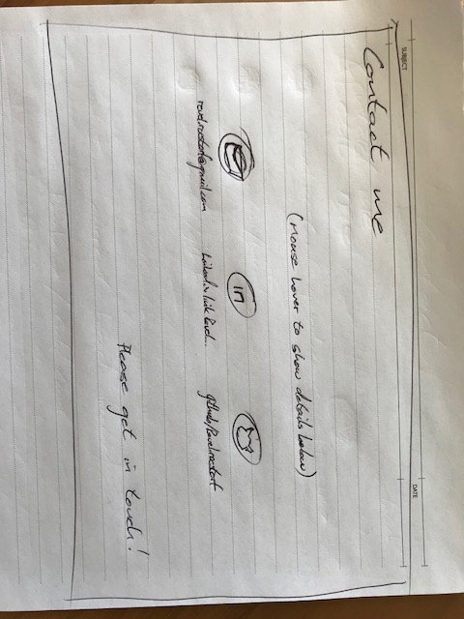

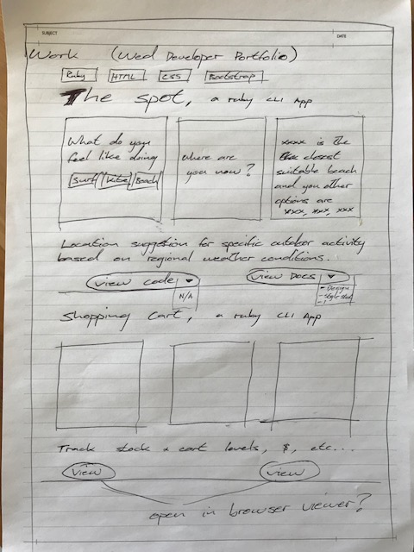

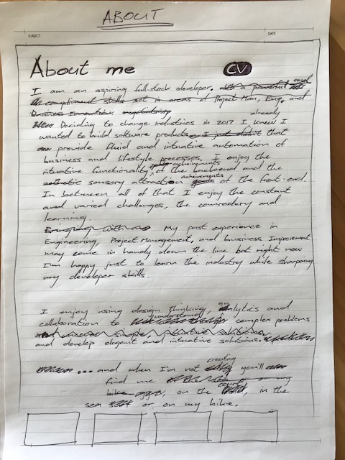

## SITE MAP

HOME

ABOUT

CONTACT

WORK

## STYLE GUIDE

### Text

The font is all neosans regular. None is bold and some is light: Nav-bar text and Work section ‘(Watch this space)’ text.

Font colours are all black except for the some white: ‘About’ and ‘Contact’ headings, work section footer bar text.

Font-sizing is all over the place and adjusted further in media queries (See code for details).

### Color

Nav-bar background is black

Page background colour is #b9bbba.

Header-box background is #EAECEE

Footer-box background is #808B96

Box borders and contact icons are #3F403F

Shadows are black

CV button is,… wait for it……………….. grey

Links are the standard blue

## LOGO

###### The logo I drew and gave to a graphic designer friend to knock up for me. It’s simply my initials in a symmetrical arrangement, which kind of looks like a stamp I think… anyway, I quite like it.

